6 Tips for Interpretable Topic Models

With so much text outputted on digital platforms, the ability to automatically understand key topic trends can reveal tremendous insight. For example, businesses can benefit from understanding customer conversation trends around their brand and products. A common method to pick up key topics is Latent Dirichlet Allocation (LDA). However, outputs are often difficult to interpret for useful insights. We will explore techniques to enhance interpretability.

What is Latent Dirichlet Allocation (LDA)?

Latent Dirichlet Allocation (LDA) is a generative statistical model that helps pick up similarities across a collection of different data parts. In topic modeling, each data part is a word document (e.g. a single review on a product page) and the collection of documents is a corpus (e.g. all users’ reviews for a product page). Similar sets of words occurring repeatedly may likely indicate topics.

LDA assumes that each document is represented by a distribution of a fixed number of topics, and each topic is a distribution of words.
Algorithm’s high level key steps to approximate these distributions:
- User select K, the number of topics present, tuned to fit each dataset.
- Go through each document, and randomly assign each word to one of K topics. From this, we have a starting point for calculating document distribution of topics p(topic t|document d), proportion of words in document d that are assigned to topic t. We can also calculate topic distribution of words p(word w|topic t), proportion of word w in all documents’ words that are assigned to topic t. These will be poor approximations due to randomness.
- To improve approximations, we iterate through each document. For each document, go through each word and reassign a new topic, where we choose topic t with a probability p(topic t|document d) ∗p(word w|topic t) based on last round’s distribution. This is essentially the probability that topic t generated word w. Recalculate p(topic t|document d) and p(word w|topic t) from these new assignments.
- Keep iterating until topic/word assignments reach a steady state and no longer change much, (i.e. converge). Use final assignments to estimate topic mixtures of each document (% words assigned to each topic within that document) and word associated to each topic (% times that word is assigned to each topic overall).

Data Preparation
We will explore techniques to optimize interpretability using LDA on Amazon Office Product reviews. To prepare the reviews data, we clean the reviews text with typical text cleaning steps:
- Remove non-ascii characters, such as À µ ∅ ©
- ‘Lemmatize’ words, which transform words to its most basic form, such as ‘running’ and ‘ran’ to ‘run’ so that they are recognized as the same word
- Remove punctuation
- Remove non-English comments if present
All code in the tutorial can be found here, where the functions for cleaning are located in clean_text.py. The main notebook for the whole process is topic_model.ipynb.

Steps to Optimize Interpretability
Tip #1: Identify phrases through n-grams and filter noun-type structures
We want to identify phrases so the topic model can recognize them. Bigrams are phrases containing 2 words e.g. ‘social media’. Likewise, trigrams are phrases containing 3 words e.g. ‘Proctor and Gamble’. There are many ways to detect n-grams, explained here. In this example, we will use Pointwise Mutual Information (PMI) score. This measures how much more likely the words co-occur than if they were independent. The metric is sensitive to rare combination of words, so it is used with an occurrence frequency filter to ensure phrase relevance. Bigram example below (trigram code included in Jupyter Notebook):
# Example for detecting bigrams
bigram_measures = nltk.collocations.BigramAssocMeasures()finder =nltk.collocations.BigramCollocationFinder\
.from_documents([comment.split() for comment in\ clean_reviews.reviewText])# Filter only those that occur at least 50 times
finder.apply_freq_filter(50)
bigram_scores = finder.score_ngrams(bigram_measures.pmi)
Additionally, we filter bigrams or trigrams with noun structures. This helps the LDA model better cluster topics, as nouns are better indicators of a topic being talked about. We use NLTK package to tag part of speech and filter these structures.
# Example filter for noun-type structures bigrams
def bigram_filter(bigram):
tag = nltk.pos_tag(bigram)
if tag[0][1] not in ['JJ', 'NN'] and tag[1][1] not in ['NN']:
return False
if bigram[0] in stop_word_list or bigram[1] in stop_word_list:
return False
if 'n' in bigram or 't' in bigram:
return False
if 'PRON' in bigram:
return False
return True# Can eyeball list and choose PMI threshold where n-grams stop making sense
# In this case, get top 500 bigrams/trigrams with highest PMI score
filtered_bigram = bigram_pmi[bigram_pmi.apply(lambda bigram:\ bigram_filter(bigram['bigram'])\
and bigram.pmi > 5, axis = 1)][:500]bigrams = [' '.join(x) for x in filtered_bigram.bigram.values\
if len(x[0]) > 2 or len(x[1]) > 2]
Lastly, we concatenate these phrases together into one word.
def replace_ngram(x):
for gram in bigrams:
x = x.replace(gram, '_'.join(gram.split()))
for gram in trigrams:
x = x.replace(gram, '_'.join(gram.split()))
return xreviews_w_ngrams = clean_reviews.copy()
reviews_w_ngrams.reviewText = reviews_w_ngrams.reviewText\
.map(lambda x: replace_ngram(x))
Tip #2: Filter remaining words for nouns
In the sentence, ‘The store is nice’, we know the sentence is talking about ‘store’. The other words in the sentence provide more context and explanation about the topic (‘store’) itself. Therefore, filtering for noun extracts words that are more interpretable for the topic model. An alternative is also to filter for both nouns and verbs.
# Tokenize reviews + remove stop words + remove names + remove words with less than 2 characters
reviews_w_ngrams = reviews_w_ngrams.reviewText.map(lambda x: [word for word in x.split()\
if word not in stop_word_list\
and word not in english_names\
and len(word) > 2])# Filter for only nouns
def noun_only(x):
pos_comment = nltk.pos_tag(x)
filtered =[word[0] for word in pos_comment if word[1] in ['NN']]
return filteredfinal_reviews = reviews_w_ngrams.map(noun_only)
Tip #3: Optimize choice for number of topics through coherence measure
LDA requires specifying the number of topics. We can tune this through optimization of measures such as predictive likelihood, perplexity, and coherence. Much literature has indicated that maximizing a coherence measure, named Cv [1], leads to better human interpretability. We can test out a number of topics and asses the Cv measure:
coherence = []
for k in range(5,25):
print('Round: '+str(k))
Lda = gensim.models.ldamodel.LdaModel
ldamodel = Lda(doc_term_matrix, num_topics=k, \
id2word = dictionary, passes=40,\
iterations=200, chunksize = 10000, eval_every = None)

cm = gensim.models.coherencemodel.CoherenceModel(\
model=ldamodel, texts=final_reviews,\
dictionary=dictionary, coherence='c_v')

coherence.append((k,cm.get_coherence()))
Plotting this shows:
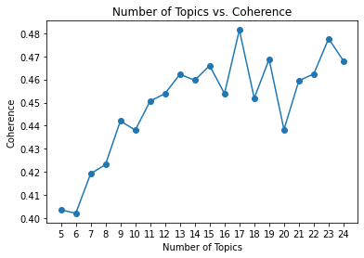
The improvement stops significantly improving after 15 topics. It is not always best where the highest Cv is, so we can try multiple to find the best result. We tried 15 and 23 here, and 23 yielded clearer results. Adding topics can help reveal further sub topics. Nonetheless, if the same words start to appear across multiple topics, the number of topics is too high.
Tip #4: Adjust LDA hyperparameters
Lda2 = gensim.models.ldamodel.LdaModel
ldamodel2 = Lda(doc_term_matrix, num_topics=23, id2word = dictionary, passes=40,iterations=200, chunksize = 10000, eval_every = None, random_state=0)
If your topics still do not make sense, try increasing passes and iterations, while increasing chunksize to the extent your memory can handle.
chunksize is the number of documents to be loaded into memory each time for training.passes is the number of training iterations through the entire corpus. iterations is the maximum iterations over each document to reach convergence — limiting this means that some documents may not converge in time. If the training corpus has 200 documents, chunksize is 100, passes is 2, and iterations is 10, algorithm goes through these rounds:
Round #1: documents 0–99
Round #2: documents 100–199
Round #3: documents 0–99
Round #4: documents 100–199
Each round will iterate each document’s probability distribution assignments for a maximum of 10 times, moving to the next document before 10 times if it already reached convergence. This is basically algorithm’s key steps 2–4 explained earlier, repeated for the number of passes, while step 3 is repeated for 10 iterationsor less.
The topic distributions for entire corpus is updated after each chunksize, and after each passes. Increasing chunksize to the extent your memory can handle will increase speed as topic distribution update is expensive. However, increasing chunksize requires increasing number of passes to ensure sufficient corpus topic distribution updates, especially in small corpuses. iterations also needs to be high enough to ensure a good amount of documents reach convergence before moving on. We can try increasing these parameters when topics still don’t make sense, but logging can also help debug:
import logging
logging.basicConfig(filename='gensim.log',
format="%(asctime)s:%(levelname)s:%(message)s",
level=logging.INFO)
Look for a lines that look like this in the log, which will repeat for the number of passes that you set:
2020-07-21 06:44:16,300 - gensim.models.ldamodel - DEBUG - 100/35600 documents converged within 200 iterations
By the end of the passes, most of the documents should have converged. If not, increase passes and iterations.
Tip #5: Use pyLDAvis to visualize topic relationships
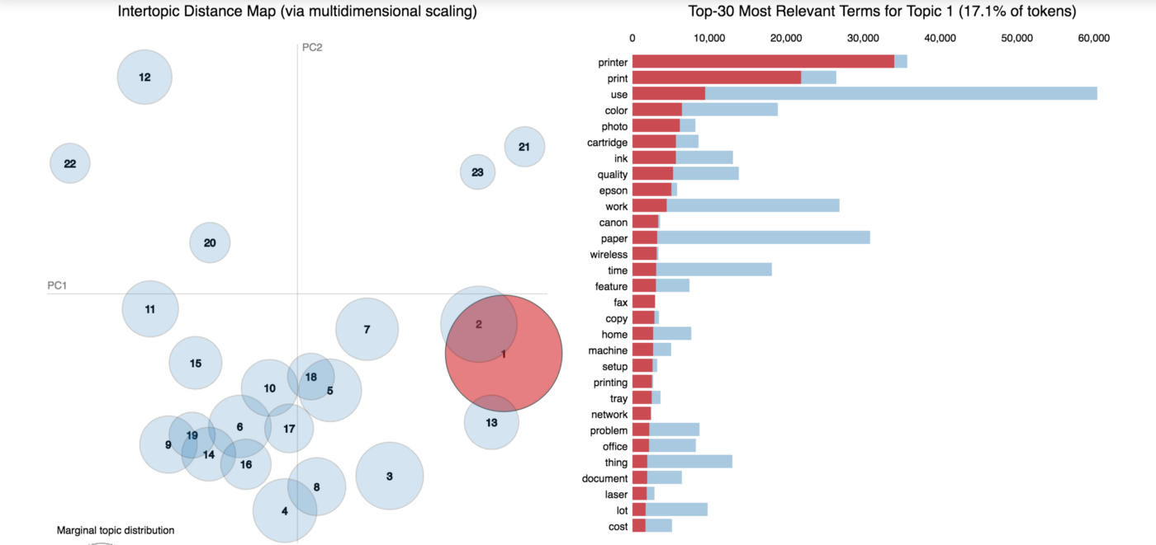
The pyLDAvis [2] package in Python gives two important pieces of information. The circles represent each topic. The distance between the circles visualizes topic relatedness. These are mapped through dimensionality reduction (PCA/t-sne) on distances between each topic’s probability distributions into 2D space. This shows whether our model developed distinct topics. We want to tune model parameters and number of topics to minimize circle overlap.
Topic distance also shows how related topics are. Topics 1,2,13 clustered together talk about electronics (printers, scanners, phone/fax). Topics in quadrant 3 such as 6,14,19 are about office stationary (packaging materials, post-its, file organizer). Additionally, circle size represents topic prevalence. For example, topic 1 makes up the biggest portion of topics being talked about amongst documents, constituting 17.1% of the tokens.
Tip #6: Tune relevancy score to prioritize terms more exclusive to a topic
Words representing a given topic may be ranked high because they are globally frequent across a corpus. Relevancy score helps prioritize terms that belong more exclusively to a given topic, making the topic more obvious. The relevance of term w to topic k is defined as:
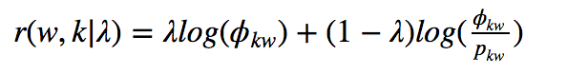
where ϕ_kw is the probability of word w in topic k and ϕ_kw/p_kw is the lift in term’s probability within a topic to its marginal probability across the entire corpus (this helps discards globally frequent terms). A lower λ gives more importance to the second term (ϕ_kw/p_kw), which gives more importance to topic exclusivity. We can again use pyLDAvis for this. For instance, when lowering λ to 0.6, we can see that topic 13 ranked terms that are even more relevant to the topic of phones.
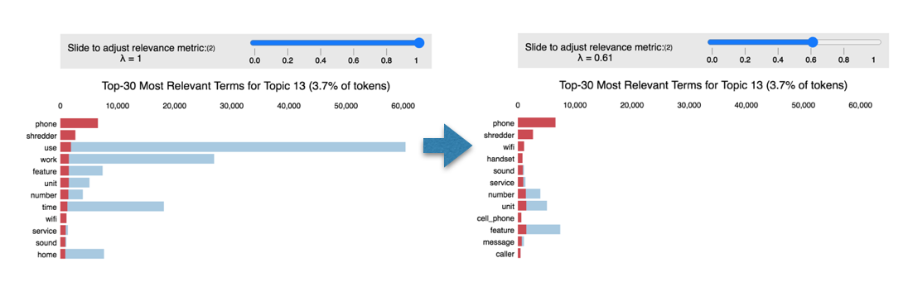
Dial the lambda around to get the result that makes the most sense and apply the optimal lambda value to obtain the output:
all_topics = {}
lambd = 0.6 # Adjust this accordingly
for i in range(1,22): #Adjust number of topics in final model
topic = topic_data.topic_info[topic_data.topic_info\
.Category == 'Topic'+str(i)]
topic['relevance'] = topic['loglift']*(1-lambd)\
+topic['logprob']*lambd
all_topics['Topic '+str(i)] = topic.sort_values(by='relevance\
, ascending=False).Term[:10].values

Final Results
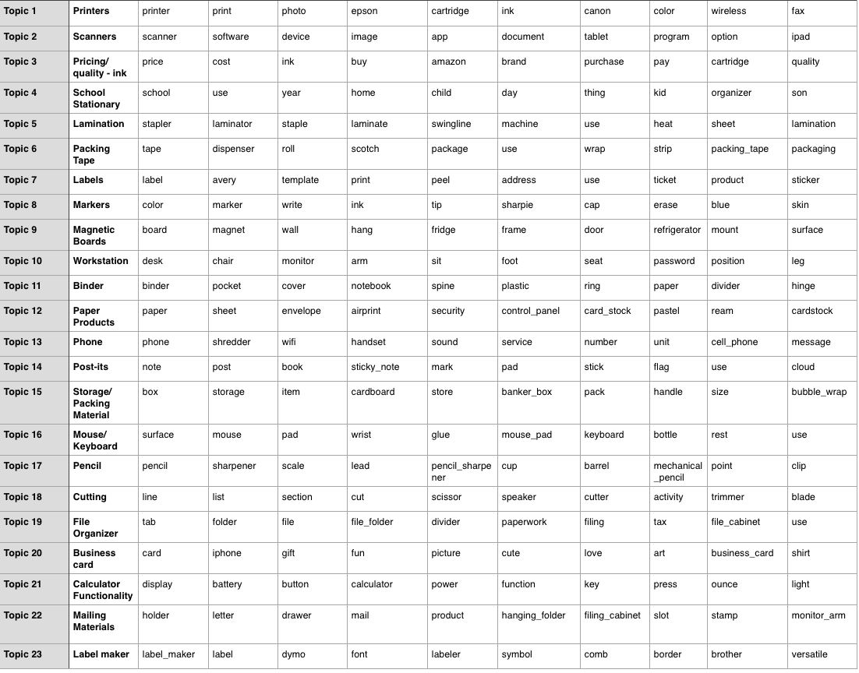
From here, we can further analyze sentiment around these topics keywords (e.g. search for adjectives or reviews star ratings associated). In business applications, this provides insight into which topics customers deem important, as well as how they feel about it. This enables targeted product development and customer experience improvements. This example contains a variety of products, but a separate topic model into each product may reveal aspects that customers care about. For example, this analysis already started to reveal important aspects of calculators (topic 21) such as display, easy to press buttons, battery, weight. Sellers then need to make sure to highlight these features in their product descriptions or improve upon these aspects for competitiveness.

Sources:
[1] Michael Röder, Andreas Both, Alexander Hinneburg, Exploring the Space of Topic Coherence Measures
[2] Carson Sievert, Kenneth E. Shirley, LDAvis: A method for visualizing and interpreting topics

